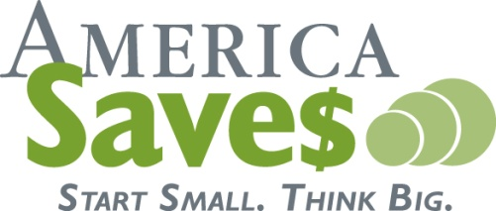
(your logo here)

Use Your Tax Refund For Debt Relief
Do you spend weeks eagerly anticipating your tax refund? When the money finally comes in, is it gone tomorrow? Many people view tax refunds as unplanned bonuses. They see the money as a gift from the government, to use for splurges or treats. A tax refund provides the opportunity to improve your financial situation. Use these tips to get the most value from your refund check.
- Pay down your debt. Use your refund for some much needed debt relief. Pay off your credit card balance. If you have an outstanding balance on more than one credit card, try to pay off the smaller, high-interest rate balances first. That will free up more funds to put toward larger balances. Alternatively, you can apply your refund toward other debts, like a car loan or a home equity loan.
- Consider your financial goals. Trying to save for a house or car down payment? Hope to contribute to your child's college tuition? Consider applying your tax refund toward these goals. If you don't yet have a set of short-term and long-term financial goals, put one together. You'll be more conscientious about how you spend your refund or any other extra money that comes your way.
- Save for a rainy day. Why not give yourself an even bigger return on your tax refund by putting the money into a savings account, CD or retirement fund? Your tax refund will continue to grow if you put it into savings or invest the money. It's always helpful to have a savings account to draw from when a major car repair bill, medical emergency or other unexpected expense comes along. That way, you don't have to borrow money and add to your debt-load.
- Keep things in perspective. Working your way out of debt can seem like a daunting task. Perhaps you assume that a small tax refund check won't make enough of a dent in your debt. Think again. Every little bit helps. Paying down debt takes time, but steadily increasing your monthly payments does have an impact. Just stay focused on the end goal. It may take years to pay off your debt, but your ultimate reward will be well worth the effort.
- If debt is a continuing problem. Certified credit counselors can help educate you on money management and teach you how to make the most of your hard-earned income. If you're having problems paying down debt, contact the local Consumer Credit Counseling Service at 490-5620. They can also enroll you in a debt management program.
- If you're doing okay. Even if your finances are in good shape, your refund check provides the opportunity to improve your life or the lives of others. Use the money to spruce up your home (replace the siding, stain the deck, etc.) or make it more energy-efficient (buy a new heater or replace drafty windows). You could improve your career opportunities by taking a class or training course. Use your refund to teach your older children how to handle money. Give them a portion of the refund and help them budget for school, clothing and entertainment expenses and savings. Finally, you may want to donate your tax refund to a worthy charitable organization. You'll help improve the lives of others, and your charitable gift may reduce next year's tax burden.
Remember, you work hard for your money and you deserve to enjoy a healthy financial lifestyle. Put some thought into how you use your tax refund. Making smart financial decisions is not always easy, but it will definitely benefit you and your family over the long term.

Content provided by Tennessee Saves and America Saves
For more information visit http://www.AmericaSaves.org

